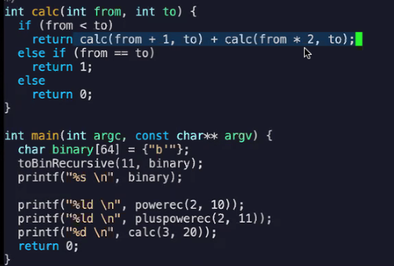

int calc(int from, int to) {

if (from < to)

return calc(from+1, to) + calc (from\*2,to);

else if (from == to)

Return 1;

else

Return 0;

}